Run Name  Date  Donate online at  http://www.funrun101.com/eventURL  Make checks payable to Organization.  Return pledges in this collection envelope  to school by Date. | Name: _____________________________  Grade: ____ Teacher: ________________  Phone: _____________________________  Email:______________________________  LAPS COMPLETED: ________

This script can be used by students when asking for pledges:

“I will be participating in my school’s fun run. For 20 minutes, I will run laps on our field. Funds raised will help purchase supplies and finance programs at my school. Will you help by sponsoring me?”

On average, students complete the following number of laps:

K: 19 laps 1st: 22 laps 2nd: 22 laps 3rd: 24 laps 4th: 26 laps 5th: 27 laps 6th: 27 laps 7th: 28 laps 8th: 29 laps

Sponsor can make a flat donation or a per lap donation.

Examples: A student runs 27 laps and has a flat donation of $20.00. Record a $20.00 Total Donation.
A student runs 27 laps and has a pledge for $1.00 per lap. Calculate $1.00 x 27 = $27.00 Total Donation.

Cash/Check donations are entered into the pledge tracking system and will appear on student’s Online Pledge Page.
Check the “Anonymous” box if you DO NOT want the Sponsor Name to be listed with their donation.
Enter an email address if the Sponsor wants a donation receipt.

Sponsor Name |  | Anonymous | Email Address | Pledge Amount |  | Online | Cash | Check
 |  | Anonymous | Email Address | flat donation | per  lap | Online | Cash | Check
1
2
3
4
5
6
7
8
 |  |  |  |  |  | Online Total | Cash Total | Check Total
 |  |  |  |  |  | TOTAL: _____________
http://www.funrun101.com


Run Name
Pledge Packet

Organization’s Fundraiser and school spirit activity is a run that will take place on the school field.
Families are invited to come and cheer for their students as they complete laps in both traditional
and non-traditional ways.

Date

K & 1: 9:00-10:00
2 & 3: 10:00-11:00
4 & 5: 11:00-12:00

IN THIS PACKET:

Pledge Tracking: Use this envelope/pledge tracking sheet to track sponsors who donate with cash/check and to record donations made online. Turn this in after the run with all cash/check donations.

All About the Event Name: A description of the event and its goals.

Online Pledge Instructions: Follow the instructions on this page to access your student’s personal donation page. Pages are already set up – you just need to access it and share it!

Prize List: A description of the prizes that can be earned by fundraising.

Participation Instructions: Permission instructions for student to participate in Event Name.

COMING HOME ON RACE DAY:

Total Laps Ran Sheet: The number of laps your student ran will be reported and final instructions given.

Prize List: A description of the prizes that can be earned by fundraising.

DATES TO REMEMBER:

Date: Get pledges
Date: Event Name
Date: Pledges due
Date: Recognition assembly
Date: Milestone Prizes delivered

If you have any questions about the Run Name contact name at phone number or email.

All About the
Run Name

What is the Run Name?
- A school wide event on date in which all students and staff participate.
- A new approach to fundraising that avoids selling products and directs all profits back to the school.
- Organization’s Fundraiser, where students are encouraged to get pledges and run laps to raise money
for Organization programming.
What are the goals of the Run Name?
- To fund Organization programming, including teacher allowances, assemblies, classroom technology and field trip opportunities.
- To include the entire School community in a fun and healthy activity.
- To be successful enough to make this the only major Organization fundraiser of the year.

What do students do for the Run Name?
- Use the online pledge system and/or the pledge sheet to collect sponsors for the Run Name.
- Run/walk a looped track on the school field for 20 minutes on the Run Name day. Each session of the Run
Name takes 1 hour, with time to get on the field, warm up, run, cool down and have a post-race snack.
- Have a ton of fun, whether or not they have pledges.
What do parents/caregivers do for the Run Name?
- Help your student get sponsors before the Run Name.
- Volunteer the day of the Run Name.
- Dress your student appropriately for running and the weather the day of the Run Name.
- Support their students with words of encouragement and by cheering from the sideline as they participate in this fun and healthy fundraising event. Signs, crazy outfits, and noisemakers are welcome!
- Help your student collect pledges and thank their sponsors after the Run Name.

What do students get from the Run Name?
- An understanding of the fun and importance of exercise.
- An appreciation of teamwork and the strong school unity at School Name.
- A FREE t-shirt and healthy snack on Run Name day.
- A chance to earn fantastic prizes.

What about pledges?
- Sponsors can pledge an amount per lap or a set amount.
- Organization is a 501(3)c organization and donations are tax-deductible. Online donors receive an email receipt. For cash donations less than $250, a cleared check image serves as a receipt.
- If your family prefers not to solicit pledges, please consider making a donation to Organization.
What happens after the Run Name?
- A packet indicating how many laps your student ran will come home on race day.
- Students should collect outstanding pledges, with checks payable to Organization.
- Turn in pledges in the pledge envelope by date.

Event Name ONLINE Pledge Instructions

http://www.funrun101.com/eventURL

What are the benefits of online pledging vs. offline pledging?
- Allow friends and family around the country to easily contribute to your student
- Reach more potential donors by sharing your student’s donation page via email and social media
- Avoid following up with donors and asking for checks after the event

How do I access my student’s personal donation page?
- Go to http://www.funrun101.com/eventURL
- Search for your student’s name in the “Search for Participant” field
- Select their name when it appears and it will take you to their personal donation page
SCHOOL HOME PAGE PERSONAL DONATION PAGE
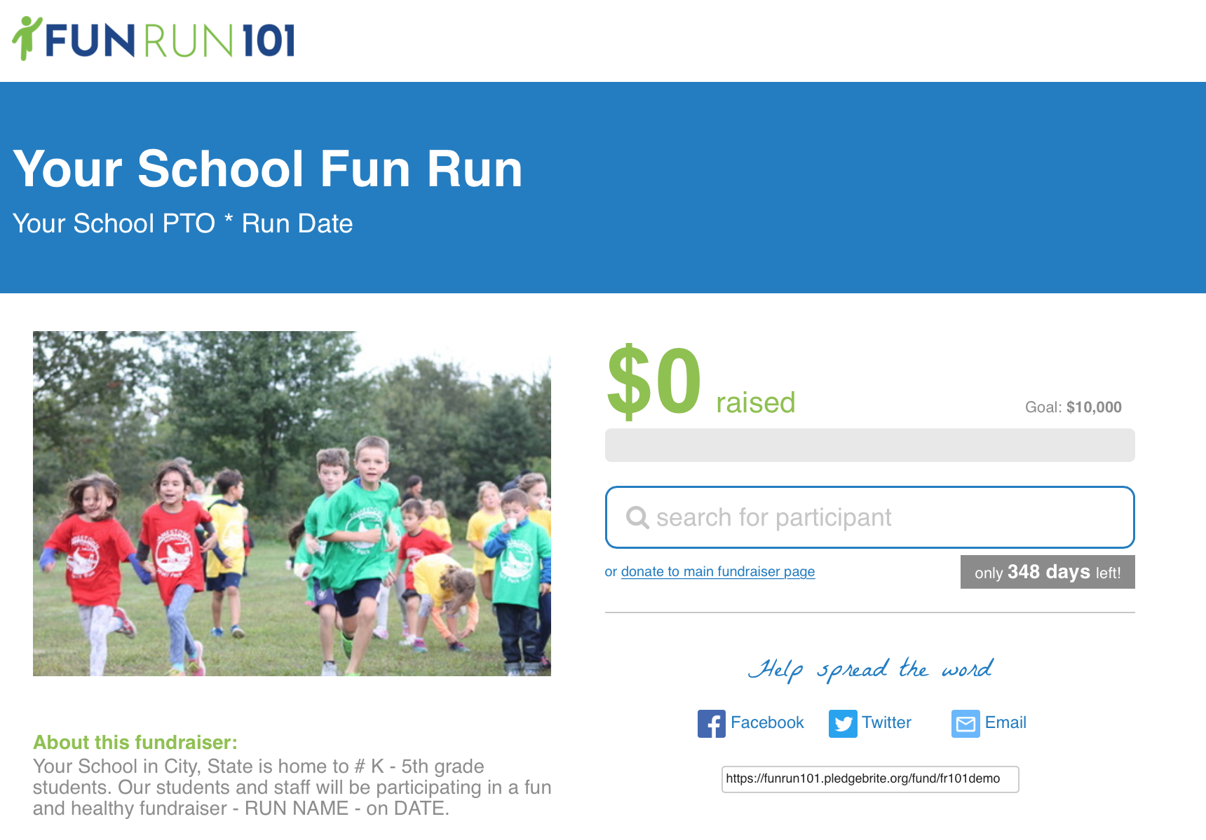 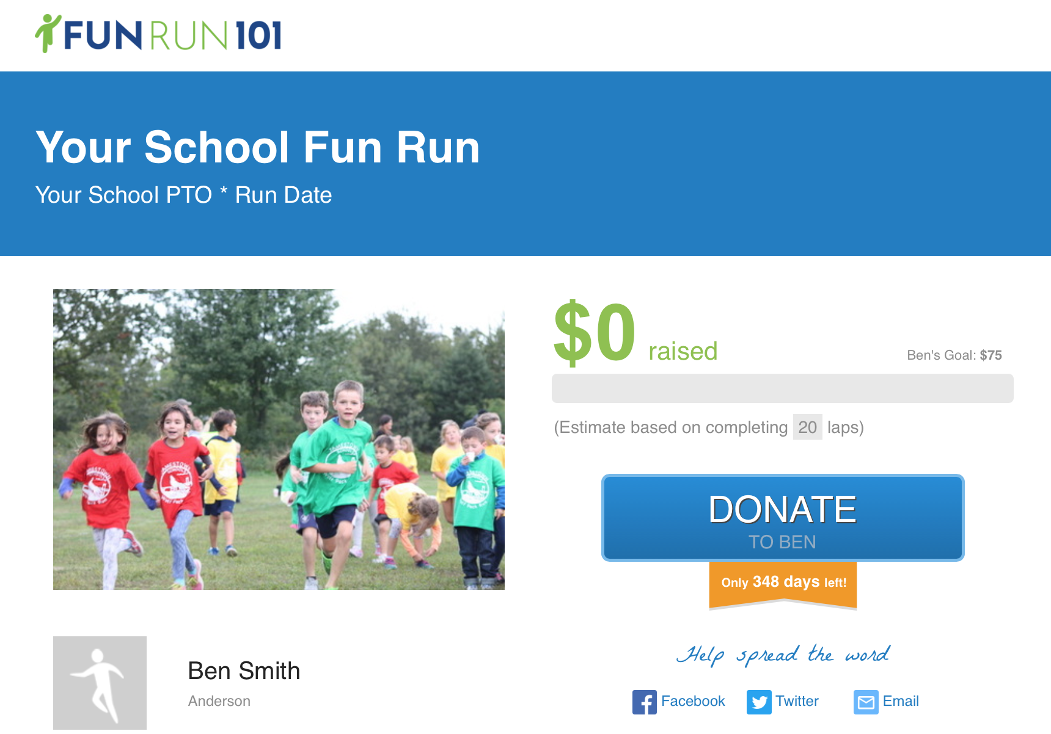

How do I use my student’s personal donation page?
- Copy the link and post it in emails to friends and family
- Share the link via social media
- Donors will click the blue “Donate” button and have the option to pledge either a flat amount or per lap
- Monitor the online donations that are made via the personal donation page
How are “per lap” donations calculated?
- If a per lap donation is made, the system will use the average laps ran to calculate an estimated donation amount to display on your page leading up to the Event Name
- After the Event Name, admin will enter the actual laps ran
- The system will then calculate actual donation amounts and charge donors accordingly

Can I edit my student’s personal donation page?
- If you want to make changes to your student’s name, fundraising goal, messaging or picture, send an email to email address and they will grant you access to edit your personal donation page.

If you experience problems contact name at phone number or email address.

Run Name Prize List

All students receive a FREE t-shirt on race day!

ALL-SCHOOL FUNDRAISING REWARDS
$X.00: all students will earn prize
$Y.00: all students will earn prize
$Z.00: all students will earn prize

ALL-CLASS FUNDRAISING REWARDS
$X.00: class will earn prize
$Y.00: class will earn prize

INDIVIDUAL FUNDRAISING REWARDS
TOP FUNDRAISER: The top fundraiser from the school will receive prize

FUNDRAISING MILESTONES: Each student who gets a donation of any amount will receive prize.
Each student who raises $75+ will receive prize.
Each student who raises $150+ will receive prize.
Each student who raises $300+ will receive prize.

PRIZE DRAWINGS
Every student will be entered to win ONE of the following prizes:

Insert prize list and/or pictures

THANK YOU TO OUR SPONSORS!

PLATINUM SPONSORS  List  List  List  List | GOLD SPONSORS  List  List  List  List | SILVER SPONSORS  List  List  List  List | BRONZE SPONSORS  List  List  List  List | IN-KIND DONORS  List  List  List  List

Event Name and Year
Participation Form

***SIGN AND RETURN THIS FORM FOR ALL STUDENTS***
All students participate in the running portion of the Event Name, regardless of
whether or not they fundraise.

Participation and Photo Release Statement
I, for myself, my child/children heirs, successors, and executors hereby ASSUME ALL RISK AND KNOWINGLY AND INTENTIONALLY WAIVE AND RELEASE, INDEMNIFY AND HOLD HARMLESS Fun Run 101 LLC, its directors, officers, agents, employees, and volunteers from and against any and all claims, actions, liabilities, suits, expenses (including reasonable attorney’s fees) which are related to, arise out of, or are in any way connected with my participation in this activity including, but not limited to, NEGLIGENCE of any kind or nature, whether foreseen or unforeseen, arising directly or indirectly out of any damage, loss, injury, paralysis, or death to me or my property as a result of my engaging in these activities or the use of these services, whether such damage, loss, injury, paralysis, or death results from negligence of Fun Run 101 LLC, its directors, officers, agents, employees, and volunteers or from some other cause. Further, on behalf of myself and my child, I hereby grant Fun Run permission to use my and/or my child’s likeness in a photograph in any and all of its publications, including website entries, without payment or any other consideration. I hereby irrevocably authorize Fun Run 101 LLC to edit, alter, copy, exhibit, publish or distribute any photo for any lawful purpose. Additionally, I waive any right to royalties or other compensation arising or related to the use of the photograph.

_________________________________
Child’s name

_________________________________
Name

_________________________________
Signature

School Name
School Address
School Address

Run Name
Participation and Photo Opt-Out

If you wish to opt your student out of participating in the Run Name and/or having their picture used for publicity or promotional purposes, please complete this form and return it to school before the date of the Run Name.
DO NOT return this form unless you are opting your student out. All students are able to participate in the running portion of the Run Name, regardless of whether or not they choose to fundraise. By not returning this form, your consent to the Release Statement below is implied.

Participation and Photo Release Statement
I, for myself, my child/children heirs, successors, and executors hereby ASSUME ALL RISK AND KNOWINGLY AND INTENTIONALLY WAIVE AND RELEASE, INDEMNIFY AND HOLD HARMLESS Fun Run 101 LLC, its directors, officers, agents, employees, and volunteers from and against any and all claims, actions, liabilities, suits, expenses (including reasonable attorney’s fees) which are related to, arise out of, or are in any way connected with my participation in this activity including, but not limited to, NEGLIGENCE of any kind or nature, whether foreseen or unforeseen, arising directly or indirectly out of any damage, loss, injury, paralysis, or death to me or my property as a result of my engaging in these activities or the use of these services, whether such damage, loss, injury, paralysis, or death results from negligence of Fun Run 101 LLC, its directors, officers, agents, employees, and volunteers or from some other cause. Further, on behalf of myself and my child, I hereby grant Fun Run permission to use my and/or my child’s likeness in a photograph in any and all of its publications, including website entries, without payment or any other consideration. I hereby irrevocably authorize Fun Run 101 LLC to edit, alter, copy, exhibit, publish or distribute any photo for any lawful purpose. Additionally, I waive any right to royalties or other compensation arising or related to the use of the photograph.

STUDENT’S NAME ________________________________________________________________

Please check the items in which you DO NOT want your student to take part.

_____ Running Student will not participate in the Event Name.
_____Photo/Video Images of student may not be used as outlined in the above statement.

_____________________________________ ______________________
Parent/Guardian Signature Date

