Event Name ONLINE Pledge Instructions

http://www.funrun101.com/eventURL

What are the benefits of online pledging vs. offline pledging?
- Allow friends and family around the country to easily contribute to your student
- Reach more potential donors by sharing your student’s donation page via email and social media
- Avoid following up with donors and asking for checks after the event

How do I access my student’s personal donation page?
- Go to http://www.funrun101.com/eventURL
- Search for your student’s name in the “Search for Participant” field
- Select their name when it appears and it will take you to their personal donation page
SCHOOL HOME PAGE PERSONAL DONATION PAGE
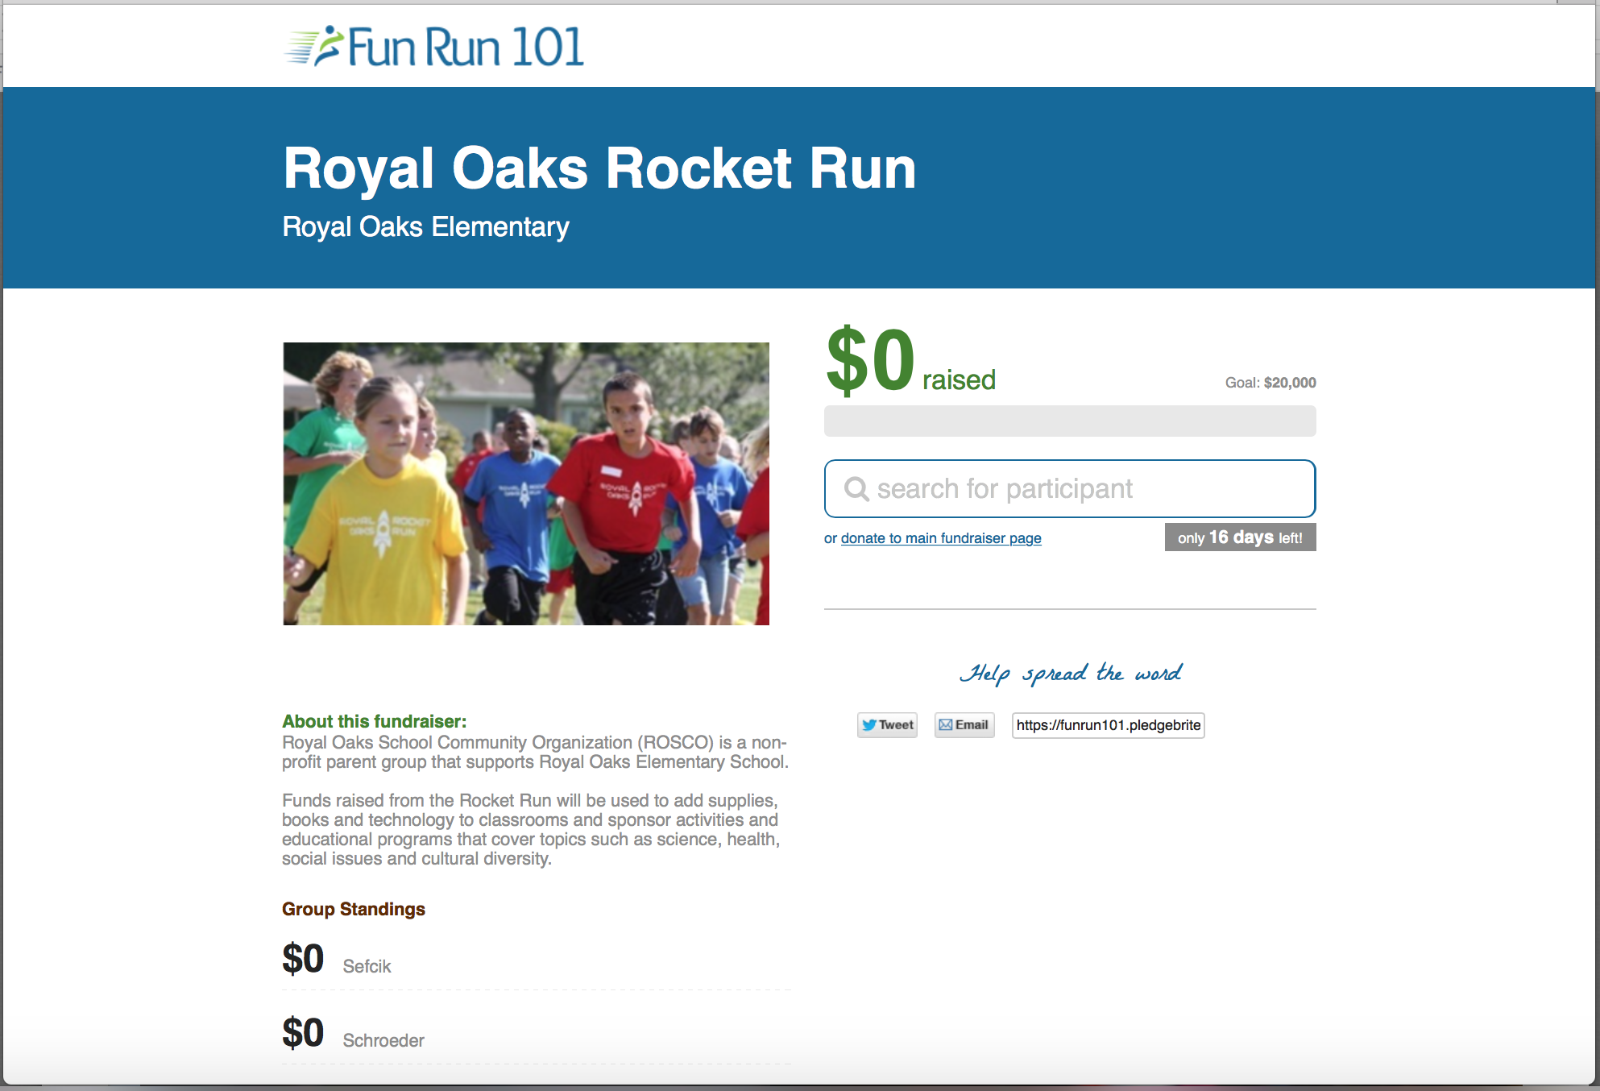 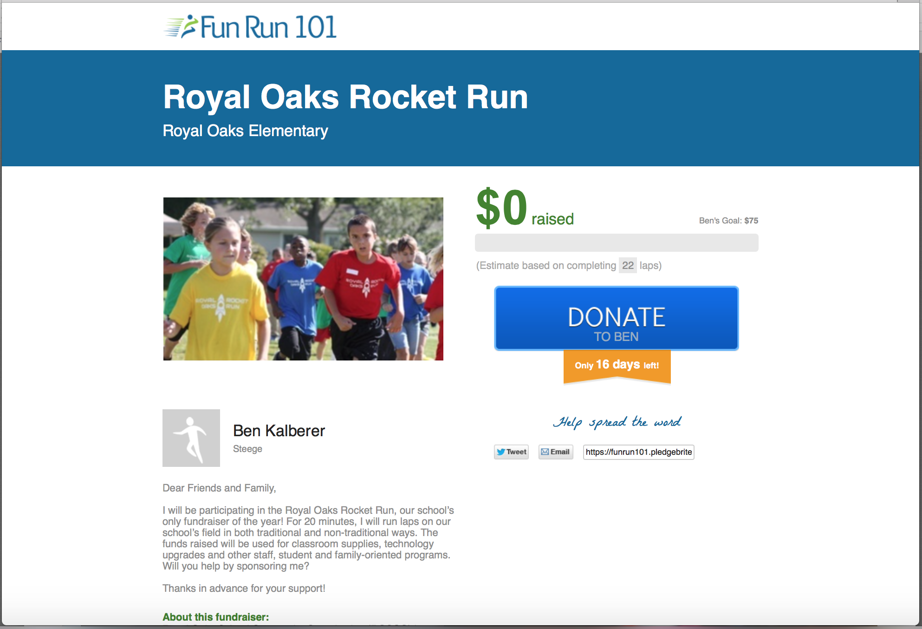

How do I use my student’s personal donation page?
- Copy the link and post it in emails to friends and family
- Share the link via social media
- Donors will click the blue “Donate” button and have the option to pledge either a flat amount or per lap
- Monitor the online donations that are made via the personal donation page
How are “per lap” donations calculated?
- If a per lap donation is made, the system will use the average laps ran to calculate an estimated donation amount to display on your page leading up to the Event Name
- After the Event Name, admin will enter the actual laps ran
- The system will then calculate actual donation amounts and charge donors accordingly

Can I edit my student’s personal donation page?
- If you want the name to read differently (Ben instead of Benjamin) email the desired change to email address
- The messaging on the left cannot be changed
- The picture cannot be changed

If you experience problems contact name at phone number or email address.

